IdeationPhase

NavigatingFlight-Booking-appTemplate

|  |  |
| --- | --- |
| Date | 31January 2025 |
| TeamID | LTVIP2025TMID52738 |
| ProjectName | NavigatingFlight-Booking-App |
| MaximumMarks | 4 Marks |

# NavigatingFlight-Booking-App&IdeaPrioritization Template:

Creating a **flight booking app** involves streamlining complex travel information into a clear, intuitive user interface that supports seamless navigation across devices. An effective app designshouldenableuserstoeasilyexploreavailableflights,filterresults,managebookings, and complete secure transactions. During brainstorming, the emphasis should be on creating user-centric navigation patterns—such as logical menu structures, real-time search suggestions, and simplified checkout flows. Prioritizing usability over complexity allows for the development of a smart and accessible platform. Teams are encouraged to collaborate creatively and iterate rapidly to deliver a frictionless travel booking experience.

Usethistemplatetomapoutyourapp’snavigationanduserflowscollaboratively,whether

you'reworkingremotelyorin person.

**Reference:**<https://ui8.net/slabdsgn/products/the-flight---flight-booking-app-ui-kits>—*Flight Booking App UI Kit (for design and navigation planning)*

# Step-1:TeamGathering,CollaborationandSelecttheProblemStatement

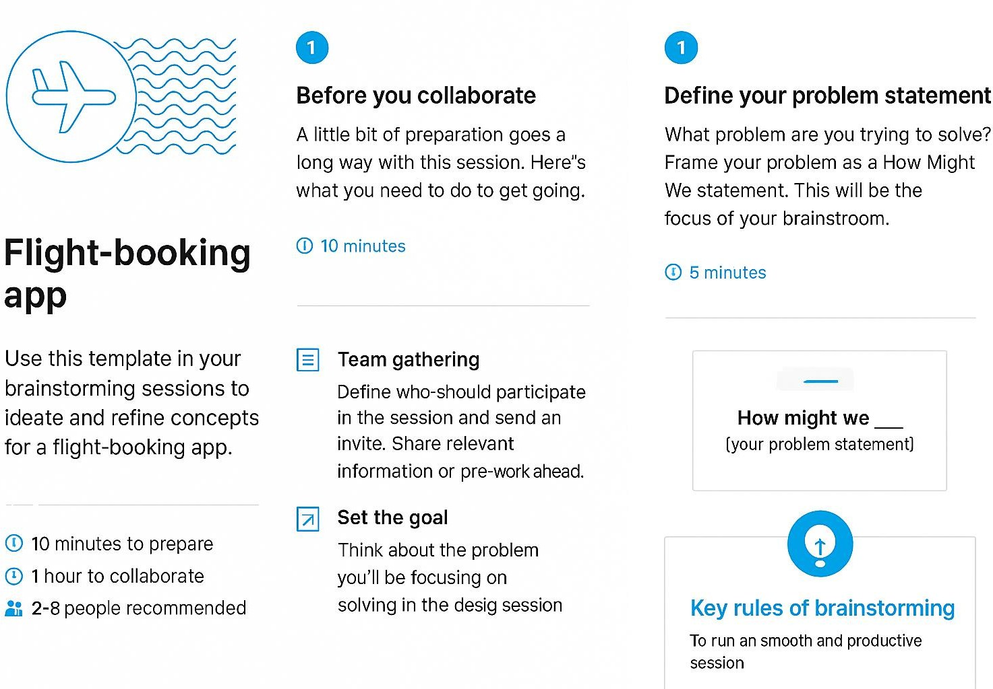

**Step-2:Flight-Booking-App,IdeaListingandGrouping**

TheflightbookingER-diagramrepresentstheentitiesandrelationshipsinvolvedinaflightbooking system. It illustrates how users, bookings, flights, passengers, and payments are interconnected.

Hereisabreakdownoftheentitiesandtheirrelationships:

**USER:**Representstheindividualsorentitieswhobookflights.Acustomercanplacemultiple bookings and make multiple payments.

**BOOKING:**Representsaspecificflightbookingmadebyacustomer.Abookingincludesaparticular flight details and passenger information. A customer can have multiple bookings.

**FLIGHT**:Representsaflightthatisavailableforbooking.Here,thedetailsofflightwillbeprovided and the users can book them as much as the available seats.

**ADMIN**:Adminisresponsibleforallthebackendactivities.Adminmanagesallthebookings,adds new flights,etc.

**Step-3:IdeaPrioritization**

|  |  |  |  |
| --- | --- | --- | --- |
| Idea | Importance | feasibility | Positionon grid |
| Real-time Flight  Tracking | High | Medium | Top-leftquadrant |
| One-clickBooking | High | High | Top-rightquadrant  ⬛ |
| LiveChatSupport | Medium | High | Mid-right |
| VoiceSearch for  Flights | Medium | Low | Bottom-left |
| LoyaltyPoints  Integration | High | Medium | Upper-mid |